Name Pranav Mathur

|  |
| --- |
| **Binary Numbers & Conversion** |

Introduction

Have you ever wondered why we use the base-ten, or decimal, number system? Of course, we have ten fingers. The decimal number system that works so well for us is completely incompatible with digital electronics. Digital electronics only understand two states, ON and OFF. This is why digital electronics use the base-two, or binary, number system. In order for you to be able to design digital electronics, you will need to be proficient at converting numbers between the decimal and binary number systems.

In this activity you will learn how to convert numbers between the decimal and binary number systems.

Procedure

1. Complete the following decimal-to-binary number conversions. An example problem is shown below.

Example:

19 (10) = __?__ (2)

Solution:

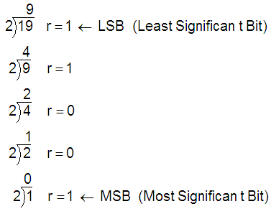

Answer:

19 (10) = 10011 (2)

Example:

23(10) = ____?____(2)

25 = 32 24 = 16 23 = 8 22 = 4 21 = 2 20 = 1

0 32-place 1 16-place 0 8-place 1 4-place 1 2-place 1 1-place

Answer: 23(10) = ____10111____(2)

1. 17 (10) = 10001 (2)
2. 34 (10) = 100010 (2)
3. 58 (10) = 111010 (2)
4. 92 (10) = 1011100 (2)
5. 119 (10) = 1110101 (2)
6. 178 (10) = 10110010 (2)
7. 297 (10) = 100101001 (2)
8. 413 (10) = 110011101 (2)
9. Complete the following binary-to-decimal number conversions. An example problem is shown below.

Example:

101001 (2) = __?__ (10)

Solution:

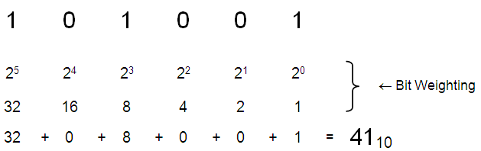

Answer:

101001 (2) = 41 (10)

1. 1100 (2) = 12 (10)
2. 11010 (2) = 26 (10)
3. 111001 (2) = 57 (10)
4. 1010011 (2) = 83 (10)
5. 10000101 (2) = 133 (10)
6. 10011001 (2) = 153 (10)
7. 100100001 (2) = 289 (10)
8. 111101010 (2) = 491 (10)
9. Perform the decimal-to-binary conversions to complete the table shown below.

|  |  |
| --- | --- |
| Decimal Number | Binary Number |
| 0 = | 0 |
| 1 = | 1 |
| 2 = | 10 |
| 3 = | 11 |
| 4 = | 100 |
| 5 = | 101 |
| 6 = | 110 |
| 7 = | 111 |
| 8 = | 1000 |
| 9 = | 1001 |
| 10 = | 1010 |
| 11 = | 1011 |
| 12 = | 1100 |
| 13 = | 1101 |
| 14 = | 1110 |
| 15 = | 1111 |

Conclusion

|  |  |
| --- | --- |
| 1. The decimal number system has served humans well since the beginning of mankind. Ug the caveman didn’t call it the decimal number system, but he undoubtedly used his fingers to count objects in his world. If the decimal system is so good, why do computer and other digital electronic devices use the binary number system? | j0089724 |

Computers use binary so that numbers can be stored in single bits, with an on/off position.

1. Now that we are using a number system other the decimal, it is important to properly subscript our numbers (i.e., 3510, 23410, 100102, etc.). Why is this so important? Provide an example where neglecting to subscript numbers could lead to confusion.

It is important so that the correct inputs can be placed into the program. Neglecting could lead to 100 (10) being input instead of 8 (10)

1. Without performing the binary-to-decimal conversions, which of the following two binary numbers is the larger number:
   * 101101 (2)  This is larger
   * 011010 (2)
2. How were you able to determine this?

The first number has a 1 in the 32 place, while the other does not.

1. Perform the binary-to-decimal conversions and check your answer. Were you correct?

Yes, 45 is bigger than 26

**Going Further – Optional**

|  |  |
| --- | --- |
| 1. What number system do you think the cartoon character at the right would use? (Hint: count the fingers). Based on the well-established *fact* that all space aliens have only three fingers on each hand, what number system do you think aliens would use? | cartoon |

The character would use 8, so they can count on their fingers

Aliens: Base 6 (10), so that they could count on their fingers

1. Use your conclusions above to complete the following conversion table.

|  |  |  |  |
| --- | --- | --- | --- |
| Decimal  Number | Binary  Number | Cartoon  Number | Alien  Number |
| 35 | 100011 | 43 | 55 |
| 22 | 10110 | 26 | 34 |